HYPERPARAMETER TUNING

Hyper parameters are external configuration variables set before training a machine learning model. They control aspects of the learning process, such as model complexity, learning rate, and architecture, and significantly influence the model's performance.

Advantages of Hyperparameter tuning

- Improved Model Performance: Finding the optimal combination of hyperparameters can significantly boost model accuracy and robustness.
- Reduced Overfitting and Underfitting: Tuning helps to prevent both overfitting and underfitting resulting in a well-balanced model.
- Enhanced Model Generalizability: By selecting hyperparameters that optimize performance on validation data the model is more likely to generalize well to unseen data.
- Optimized Resource Utilization: With careful tuning resources such as computation time and memory can be used more efficiently avoiding unnecessary work.
- Improved Model Interpretability: Properly tuned hyperparameters can make the model simpler and easier to interpret.

Hyperparameters used in decision tree:
1. criterion: [Gini, entropy, mse]
this function measures the quality of split
2. max_depth: ex. [3,5,10]
it control how much deep the tree grow, it also stop overfitting
3. min_sample_split: ex. [2,5,10]
It acts as threshold for splitting,it specify minimum number of samples required to split node
4. min_sample_leaf: ex. [2,5,10]
Ensure that each leaf have minimum number of samples ,this help in reducing variance

Hyperparameters used in Random Forest:
1. n_estimators: [10,30,50,100,500]
It defines the number of trees in forest, more number of trees increase the accuracy of model 2. max_depth:
3. min_sample_split
4. min_sample_leaf
5. Max_features :controls the number of features considered at each split , this increase the speed and performance eg.”auto” or [ “sqrt”, “log2”]
6. random state:it controls the randomness of the data or shuffling of the data. Suppose its value=0 then every time whenever we run the model it will pick random set of different records in dataset and produce different output and accuracy every time
But if it is =42,49,6 in such way ny integer value then it produce same output and same accuracy for every run of model

Types of hypeparameter tuning:

Aspect | Grid Search CV | Random Search CV
Definition | Tries all possible combinations of hyperparameters | Tries random combinations of hyperparameters
Search Strategy | Exhaustive (systematic) | Probabilistic (random sampling)
Speed | Slow when parameters are many | Faster
Computational Cost | Very high | Lower
Scalability | Poor for large parameter space | Good for large parameter space
Best Use Case | Small number of parameters with few values | Large number of parameters or wide ranges
Guarantee of Best Params | Yes (within defined grid) | No (but often close)
Control Over Search | Full control | Partial control
Overfitting Risk | Higher (due to exhaustive tuning) | Lower
Efficiency | Inefficient when many params are irrelevant | More efficient
Parallelization | Supported (n_jobs) | Supported (n_jobs)
Hyperparameter Coverage | Complete coverage | Partial coverage
Typical CV Runs | param1 × param2 × cv | n_iter × cv {in all given combinations it takes n_iter number of random combinations
When Dataset is Small | Good choice | Also good
When Dataset is Large | Not recommended | Recommended

How GridSearchCV Works
- Tries all combinations of hyperparameters
- Performs cross-validation for each combination
- Selects the model with best average score
- Avoids overfitting better than single train-test.

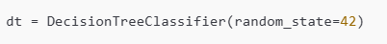
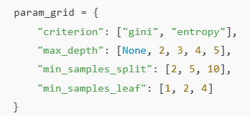
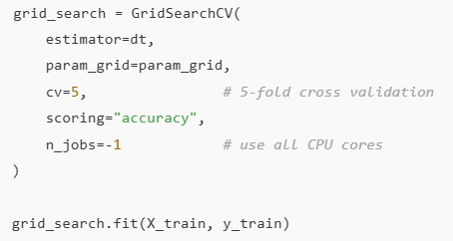
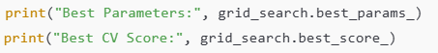
Train the model with our best estimator

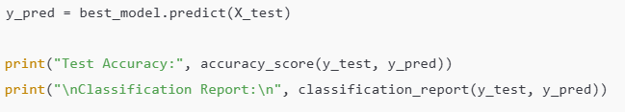

How Random Search CV Works
- Randomly samples combinations of hyperparameters
- Uses cross-validation
- Finds near-optimal parameters faster than Grid Search
